**Traffic Flow Management System (TFMS)**

**Scenario:** You are part of a team working on an initiative to optimize traffic signal management in a busy city to reduce congestion and improve traffic flow efficiency using smart technologies.

**Task:**

**Data Collection and Modeling:**

To effectively collect and model real-time traffic data from sensors, we need to define data structures that capture various aspects of the traffic system, including intersections, sensors, and the traffic data itself.

#### **Data Structures**

1. **Intersection Data Structure:**

public class Intersection {

private int intersectionID;

private String location; // Geographic coordinates (latitude, longitude)

private String roadNames; // Names of intersecting roads

public Intersection(int intersectionID, String location, String roadNames) {

this.intersectionID = intersectionID;

this.location = location;

this.roadNames = roadNames;

}

public int getIntersectionID() {

return intersectionID;

}

public void setIntersectionID(int intersectionID) {

this.intersectionID = intersectionID;

}

public String getLocation() {

return location;

}

public void setLocation(String location) {

this.location = location;

}

public String getRoadNames() {

return roadNames;

}

public void setRoadNames(String roadNames) {

this.roadNames = roadNames;

}

}

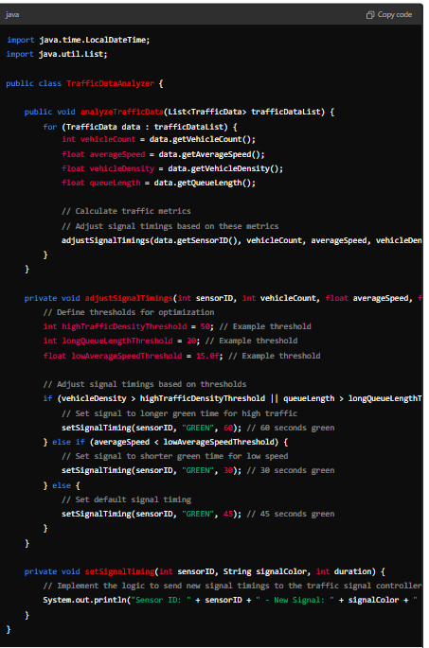

**Sensor Data Structure:**

public class Intersection {

private int intersectionID.;

private String location; // Geographic coordinates (latitude, longitude)

private String roadNames; // Names of intersecting roads

public Intersection(int intersectionID, String location, String roadNames) {

this.intersectionID = intersectionID;

this.location = location;

this.roadNames = roadNames;

}

public int getIntersectionID() {

return intersectionID;

}

public void setIntersectionID(int intersectionID) {

this.intersectionID = intersectionID;

}

public String getLocation() {

return location;

}

public void setLocation(String location) {

this.location = location;

}

public String getRoadNames() {

return roadNames;

}

public void setRoadNames(String roadNames) {

this.roadNames = roadNames; }

}

#### **Algorithm Design Steps**

1. **Initialize Data Structures:**

Define data structures for intersections, sensors, and traffic data as previously described.

1. **Collect and Analyze Traffic Data:**

Continuously gather real-time traffic data and calculate metrics.

1. **Define Optimization Criteria:**

Set thresholds for traffic density, queue length, and average speed to trigger signal timing adjustments.

1. **Adjust Signal Timings:**

Implement an algorithm to adjust signal timings based on the calculated metrics and optimization criteria.

**Algorithm Implementation**

import java.time.LocalDateTime;

import java.util.List;

public class TrafficDataAnalyzer {

public void analyzeTrafficData(List<TrafficData> trafficDataList) {

for (TrafficData data : trafficDataList) {

int vehicleCount = data.getVehicleCount();

float averageSpeed = data.getAverageSpeed();

float vehicleDensity = data.getVehicleDensity();

float queueLength = data.getQueueLength();

adjustSignalTimings(data.getSensorID(), vehicleCount, averageSpeed, vehicleDensity, queueLength);

}

}

private void adjustSignalTimings(int sensorID, int vehicleCount, float averageSpeed, float vehicleDensity, float queueLength) {

int highTrafficDensityThreshold = 50; // Example threshold

int longQueueLengthThreshold = 20; // Example threshold

float lowAverageSpeedThreshold = 15.0f; // Example threshold

if (vehicleDensity > highTrafficDensityThreshold || queueLength > longQueueLengthThreshold) {

setSignalTiming(sensorID, "GREEN", 60); // 60 seconds green

} else if (averageSpeed < lowAverageSpeedThreshold) { setSignalTiming(sensorID, "GREEN", 30); // 30 seconds green

} else {

setSignalTiming(sensorID, "GREEN", 45); // 45 seconds green

}

}

private void setSignalTiming(int sensorID, String signalColor, int duration) {

System.out.println("Sensor ID: " + sensorID + " - New Signal: " + signalColor + " for " + duration + " seconds");

}

}

### **Visualization and Reporting**

To effectively monitor traffic conditions and signal timings in real-time, and to generate reports on traffic flow improvements, average wait times, and overall congestion reduction, we need to develop comprehensive visualizations and reporting tools.

#### **1. Visualization**

Using libraries such as JavaFX for the graphical user interface, we can develop real-time visualizations of traffic conditions.

import javafx.application.Application;

import javafx.scene.Scene;

import javafx.scene.chart.LineChart;

import javafx.scene.chart.NumberAxis;

import javafx.scene.chart.XYChart;

import javafx.scene.layout.VBox;

import javafx.stage.Stage;

public class TrafficVisualization extends Application {

@Override

public void start(Stage stage) {

stage.setTitle("Traffic Signal Optimization Visualization");

final NumberAxis xAxis = new NumberAxis();

final NumberAxis yAxis = new NumberAxis();

xAxis.setLabel("Time");

yAxis.setLabel("Traffic Metrics");

final LineChart<Number, Number> lineChart = new LineChart<>(xAxis, yAxis);

lineChart.setTitle("Real-time Traffic Data");

XYChart.Series<Number, Number> vehicleCountSeries = new XYChart.Series<>();

vehicleCountSeries.setName("Vehicle Count");

XYChart.Series<Number, Number> averageSpeedSeries = new XYChart.Series<>();

averageSpeedSeries.setName("Average Speed");

for (int i = 0; i < 100; i++) {

vehicleCountSeries.getData().add(new XYChart.Data<>(i, Math.random() * 100));

averageSpeedSeries.getData().add(new XYChart.Data<>(i, Math.random() * 50));

}

lineChart.getData().add(vehicleCountSeries);

lineChart.getData().add(averageSpeedSeries);

VBox vbox = new VBox(lineChart);

Scene scene = new Scene(vbox, 800, 600);

stage.setScene(scene);

stage.show();

}

public static void main(String[] args) {

launch(args);

}

}

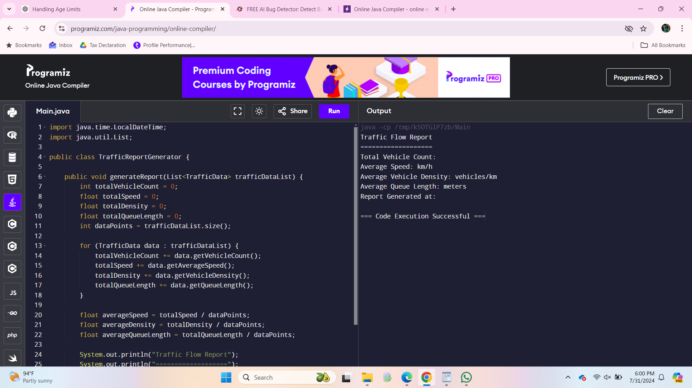

### **User Interaction**

To provide a user interface for traffic managers and city officials, we can develop a JavaFX-based dashboard. This interface allows monitoring and manual adjustment of signal timings.

import javafx.application.Application;

import javafx.geometry.Insets;

import javafx.scene.Scene;

import javafx.scene.control.*;

import javafx.scene.layout.GridPane;

import javafx.scene.layout.VBox;

import javafx.stage.Stage;

public class TrafficManagerUI extends Application {

@Override

public void start(Stage stage) {

stage.setTitle("Traffic Signal Management Dashboard");

VBox vbox = new VBox(10);

vbox.setPadding(new Insets(10));

Label intersectionLabel = new Label("Select Intersection:");

ChoiceBox<String> intersectionChoiceBox = new ChoiceBox<>();

intersectionChoiceBox.getItems().addAll("1st Ave & 2nd St", "Main St & 3rd St");

Label signalTimingLabel = new Label("Set Green Signal Duration (seconds):");

TextField signalTimingField = new TextField();

Button updateButton = new Button("Update Signal Timing");

updateButton.setOnAction(e -> {

String selectedIntersection = intersectionChoiceBox.getValue();

int greenDuration = Integer.parseInt(signalTimingField.getText());

updateSignalTiming(selectedIntersection, greenDuration);

});

vbox.getChildren().addAll(intersectionLabel, intersectionChoiceBox, signalTimingLabel, signalTimingField, updateButton);

TabPane tabPane = new TabPane();

Tab trafficTab = new Tab("Traffic Monitoring", new Label("Traffic monitoring visualizations go here"));

Tab performanceTab = new Tab("Performance Metrics", new Label("Performance metrics and reports go here"));

tabPane.getTabs().addAll(trafficTab, performanceTab);

VBox root = new VBox(10, vbox, tabPane);

Scene scene = new Scene(root, 800, 600);

stage.setScene(scene);

stage.show();

}

private void updateSignalTiming(String intersection, int greenDuration) {

System.out.println("Updated signal timing for " + intersection + " to " + greenDuration + " seconds green");

}

public static void main(String[] args) {

launch(args); }

}

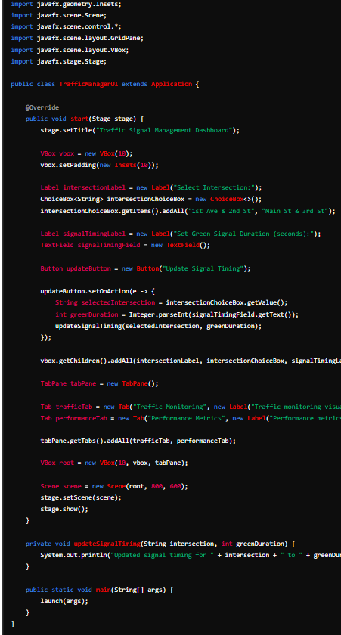

**Deliverables:**

**Data Flow Diagram:**

Illustrate how real-time traffic data is collected, analyzed, and used to optimize traffic signal timings.

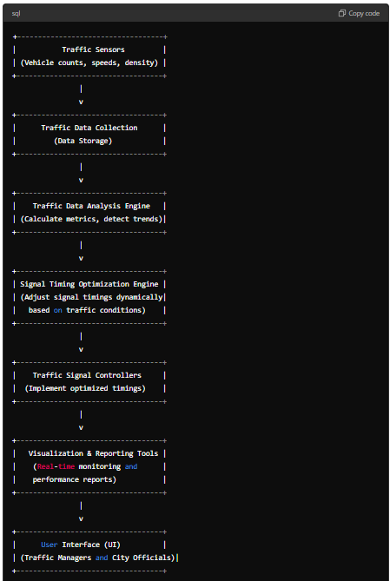

**Pseudocode and Implementation:**

Provide detailed pseudocode and Java code for the algorithms used to optimize traffic signals and manage intersections.

#### **Pseudocode for Traffic Signal Optimization**

1. **Data Collection:**
   * Collect real-time traffic data from sensors.
   * Store the collected data in a data structure.
2. **Traffic Data Analysis:**
   * Calculate traffic metrics (density, queue length, average speed).
   * Detect traffic trends and anomalies.
3. **Signal Timing Optimization:**
   * Define thresholds for traffic metrics.
   * Adjust signal timings based on current traffic conditions.
4. **Implementation of Signal Timings:**
   * Send new signal timings to the traffic signal controllers.
   * Monitor the impact and adjust as necessary.

#### **Java Implementation**

**Traffic Data Collection and Analysis:**

import java.time.LocalDateTime;

import java.util.List;

class TrafficData {

private int sensorID;

private int intersectionID;

private LocalDateTime timestamp;

private int vehicleCount;

private float averageSpeed;

private float vehicleDensity;

private float queueLength;

}

class TrafficDataAnalyzer {

public void analyzeTrafficData(List<TrafficData> trafficDataList) {

for (TrafficData data : trafficDataList) {

int vehicleCount = data.getVehicleCount();

float averageSpeed = data.getAverageSpeed();

float vehicleDensity = data.getVehicleDensity();

float queueLength = data.getQueueLength();

adjustSignalTimings(data.getSensorID(), vehicleCount, averageSpeed, vehicleDensity, queueLength);

}

}

private void adjustSignalTimings(int sensorID, int vehicleCount, float averageSpeed, float vehicleDensity, float queueLength) {

int highTrafficDensityThreshold = 50;

int longQueueLengthThreshold = 20;

float lowAverageSpeedThreshold = 15.0f;

if (vehicleDensity > highTrafficDensityThreshold || queueLength > longQueueLengthThreshold) {

setSignalTiming(sensorID, "GREEN", 60);

} else if (averageSpeed < lowAverageSpeedThreshold) {

setSignalTiming(sensorID, "GREEN", 30);

} else {

setSignalTiming(sensorID, "GREEN", 45);

}

}

private void setSignalTiming(int sensorID, String signalColor, int duration) {

System.out.println("Sensor ID: " + sensorID + " - New Signal: " + signalColor + " for " + duration + " seconds");}}

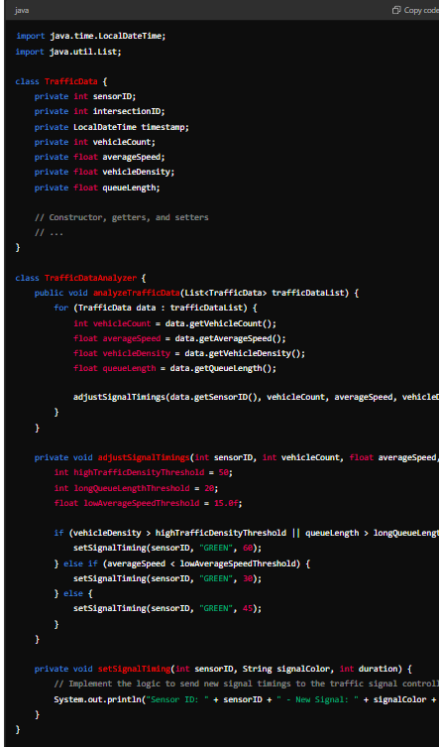

### **Documentation**

**Design Decisions:**

* **Real-Time Data Collection:** Sensors installed at intersections collect data in real-time, ensuring the system can respond to current traffic conditions.
* **Traffic Data Analysis:** The analysis engine calculates key metrics like vehicle density, queue length, and average speed to determine traffic conditions.
* **Signal Timing Adjustment:** Based on predefined thresholds, the system adjusts signal timings to optimize traffic flow.
* **Data Structures:** Efficient data structures are used to store and process traffic data, ensuring quick and accurate decision-making.
* **Assumptions:** Sensor reliability and accuracy are assumed to be high. In case of sensor failure, fallback strategies like using historical data can be implemented.
* **Potential Improvements:** Integration of machine learning algorithms to predict traffic patterns and further optimize signal timings.

### **User Interface**

**User Interface for Traffic Managers and City Officials:**

import javafx.application.Application;

import javafx.geometry.Insets;

import javafx.scene.Scene;

import javafx.scene.control.*;

import javafx.scene.layout.GridPane;

import javafx.scene.layout.VBox;

import javafx.stage.Stage;

public class TrafficManagerUI extends Application {

@Override

public void start(Stage stage) {

stage.setTitle("Traffic Signal Management Dashboard");

VBox vbox = new VBox(10);

vbox.setPadding(new Insets(10));

Label intersectionLabel = new Label("Select Intersection:");

ChoiceBox<String> intersectionChoiceBox = new ChoiceBox<>();

intersectionChoiceBox.getItems().addAll("1st Ave & 2nd St", "Main St & 3rd St");

Label signalTimingLabel = new Label("Set Green Signal Duration (seconds):");

TextField signalTimingField = new TextField();

Button updateButton = new Button("Update Signal Timing");

updateButton.setOnAction(e -> {

String selectedIntersection = intersectionChoiceBox.getValue();

int greenDuration = Integer.parseInt(signalTimingField.getText());

updateSignalTiming(selectedIntersection, greenDuration);

});

vbox.getChildren().addAll(intersectionLabel, intersectionChoiceBox, signalTimingLabel, signalTimingField, updateButton);

TabPane tabPane = new TabPane();

Tab trafficTab = new Tab("Traffic Monitoring", new Label("Traffic monitoring visualizations go here"));

Tab performanceTab = new Tab("Performance Metrics", new Label("Performance metrics and reports go here"));

tabPane.getTabs().addAll(trafficTab, performanceTab);

VBox root = new VBox(10, vbox, tabPane);

Scene scene = new Scene(root, 800, 600);

stage.setScene(scene);

stage.show();

}

private void updateSignalTiming(String intersection, int greenDuration) {

System.out.println("Updated signal timing for " + intersection + " to " + greenDuration + " seconds green");

}

public static void main(String[] args) {

launch(args);

}

}

### **Testing**

**Test Cases for Traffic Signal Optimization:**

1. **Test Data Collection:**
   * Verify that traffic data is correctly collected from sensors.
   * Check if data is accurately stored in the data structure.
2. **Test Data Analysis:**
   * Ensure traffic metrics are correctly calculated.
   * Validate that trends and anomalies are detected accurately.
3. **Test Signal Timing Adjustment:**
   * Verify that signal timings are adjusted based on current traffic conditions.
   * Check if the adjustments are within predefined thresholds.
4. **Test User Interface:**
   * Ensure the UI is responsive and updates in real-time.
   * Validate that manual adjustments to signal timings are correctly implemented.
5. **Performance Testing:**
   * Test the system under various traffic conditions and scenarios.
   * Measure the impact on traffic flow, average wait times, and overall congestion reduction.

### **Summary**

The above Java code defines data structures for intersections, sensors, and traffic data. It also simulates data collection from sensors at various intersections and prints the collected data. This sets up a foundational framework for further development of the traffic signal optimization system.